**Voice Based Hot and Cold Water Dispenser**

Prerna Biradar , Sakshi Badadhe , Pravin Bangar, Ranjeet Kate, Neha Shriwas , Asra Dhotekar

**DR.S.M.Handore, Prof.Pranjali Deshmukh**

E&TC Trinity College of Engineering and Research, Pune, Maharashtra, India

**Abstract** The Voice-Based Hot and Cold Water Dispenser is a smart, touch-free water dispensing system that operates using voice commands. This system is designed to offer convenience, hygiene, and accessibility, especially for the elderly, disabled, and in high-traffic areas. By integrating voice recognition with an ESP8266 microcontroller, temperature sensors, solenoid valves, and IR sensors, the device effectively dispenses hot or cold water on command. The system enhances usability through audio and visual feedback, while promoting energy efficiency with automatic shutdown features. This paper explores the design, methodology, hardware-software integration, and future scope of this innovative device.

*Keywords* ***:*** *Voice Recognition, ESP8266, Water Dispenser, IoT, Temperature Control, Automation, Accessibility*

**introduction** – The Voice-Based Hot and Cold-Water Dispenser is an intelligent, hands-free device that enables users to dispense water temperature and dispensing using voice commands. With the latest voice recognition technology, the system reacts to voice commands for hot, warm, or coldwater, providing increased convenience to the user. The innovation is especially useful for people with mobility issues or in a fast-paced setting where instant access is critical. The dispenser encourages energy efficiency as it controls the temperature of the water automatically. It also provides a smooth and intuitive experience, and hence is perfectly suitable for homes, offices, and public areas. On the whole, this technology provides more accessibility and efficiency in everyday water use.

**Literature Review** – incorporation of voice recognition technology into daily appliances has been a major focus in recent years, providing many benefits in terms of accessibility, convenience, and efficiency.Voice-controlled systems are increasingly prevalent in smart homes, where users can communicate with devices like thermostats, lighting, and appliances using simple voice commands.The literature review determines several key areas of development and links to voice distributors with hot and cold water.Vocal Recognition Technology: Advances Advances NLP has advanced to ensure voice recognition that voice-controlled devices are more accurate and deserve more confidence. Study by Zhu et al.(2019) explains how voice assistants such as Amazon Alexa and Google Assistant used intellectual housing to develop and influence user interfaces. The progress of these areas has made it possible to process more complex orders and thus create more advanced The applications, such as intelligent distributors.Intelligent dispensors: water distributors have been upgraded with the advent of intelligent technology, adopting features such as contactless functionalities, temperature adjustment and user interfaces.Research, for example, research XU et al.(2020), explores the possibility of water supply distributors based on the IoT, noting the growing need for automatic temperature control, which maintains the constant quality and temperature of water with a little user effort. However, there is still room for innovation in this area, as few solutions incorporate vocal interactions.Accessibility and Inclusiveness: Voice-controlled systems have been proven to improve accessibility for people with disabilities.For example, studies by Borsci et al.(2021) prove that the devices arranged with the voice can greatly benefit people with mobility or visiting vision, which allows them to carry out daily activities independently.Using this principle for water supply reveals the possibility of increased inclusion in private and public areas. Energy Efficiency: Combining intellectual temperature control and voice recognition in water supply also offers energy-saving benefits. For example, research into effective energy devices, Wang et al.(2018) show that intelligent systems can be programmed to automatically change tasks to maximize energy usage. For example, a dispenser with voice control can either turn off or change the temperature after extracting the required amount of water, saving unnecessary energy consumption.User Experience and Interaction: User Experience (UX) is the key to successful voice-controlled systems. Nielsen et al.(2020) argue that natural and fluid interaction with devices increases user satisfaction.For water dispensers, voice commands make using the device more intuitive. Users can easily configure priority water settings without manually intervening in managing the same thing.

**Purposed Methodology** – The process of creating a Voice-Based Hot and Cold Water Dispenser is a mix of hardware design, software development, and voice recognition technology integration.The focus is on designing a smart, easy-to-use dispenser that dispenses hot or cold water as instructed verbally.The process has a number of main stages:

1.System Design Hardware Choice: The dispenser will be fitted with standard hardware like water pumps, temperature sensors, heating/cooling units, and a user interface (microphone and speaker for voice commands).Vocal recognition modules: The system includes speech recognition modules such as Google Speech API, Amazon Alexa, or individual speech recognition systems that are connected to a microcontroller (such as an Arduino or Raspberry Pi) and executed commands.Temperature Control System: To measure water temperature, a temperature measuring system must be used, and heating or cooling elements must be controlled by user voice control.

2. Development of vocal recognition The vocal control database: there will be a vocal command database, covering orders for various water temperatures Natural Language Therapy (NLP): The system uses NLP algorithms to correctly analyze and interpret user language differences and provide an interface that can handle a variety of accents, voices and noise. Integration with Microcontrollers: The vocal control system provides an interface with the microcontroller, which provides instructions for operating the heating/cooling elements and water distribution processes based on the identified controls.

3.Water Dispensing System Temperature Control and Sensing: A temperature sensor is to be installed to constantly keep track of the water temperature.Depending on the verbal command of the user the system will turn on the appropriate heating or cooling arrangement to control the water temperature.Water dosage mechanism: the unit will secrete water in a checked quantity using a motorized button or opening.

4 Optimization of energy efficiency Automatic shutdown system: the mechanism will be programmed to automatically shut off units of heating/cooling after reaching a given temperature. This will help to avoid energy loss and make the dispenser more effective.Intellectual Energy Management: If a user stops interacting with the system or discovers that water has been administered, they will use very little energy to enter idle mode until the next instruction is released.

5 User Interface and Feedback Voice Feedback: When processing voice commands, the system provides auditory feedback and reports the actions taken (for example, "Press hot water now" or \"cold\" or \"). Visual Indicator: The system can use an LED indicator or display screen to visually indicate the system's status (heating, cooling, idle, etc.).

6. Testing and evaluation Prototype testing: the first prototype will be tested to assess the accuracy and responsiveness of the voice recognition system in various conditions (for example, background noise, several users).

**Proposed system Architecture**

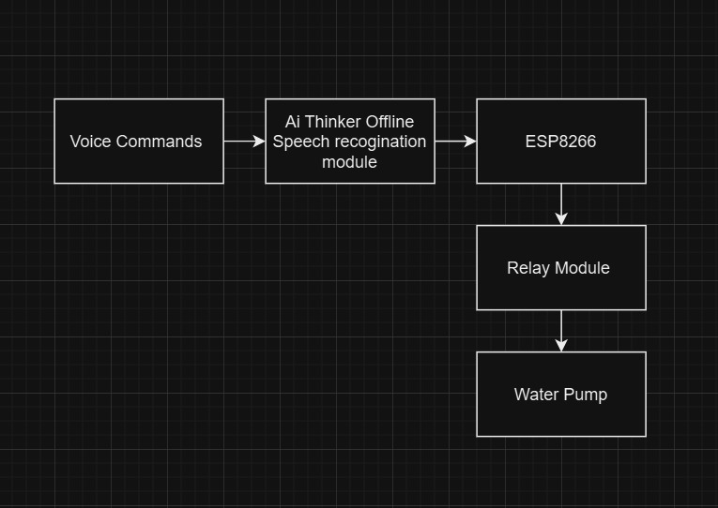

Hardware Requirements

1. ESP8266 (Wi-Fi Microcontroller Module) Function: Acts as the central processing unit, handling communication between the voice module and hardware components. Key Features: Supports Wi-Fi connectivity for IoT applications. Low power consumption. Operates at 3.3V. Usage: Processes voice commands, controls relays, and sends signals to actuate solenoid valves and pumps.

2. Voice Module Function: Converts spoken commands into electrical signals for the microcontroller. Options: Google Assistant/Alexa Integration (via ESP8266). Offline Voice Recognition Modules like Elechouse V3 or EasyVR. Usage: Recognizes commands like “Hot Water” or “Cold Water” and triggers the dispenser accordingly.

3. Solenoid Valves (x2) Function: Controls the flow of hot and cold water by opening or closing based on the ESP8266 signals. Working Principle: When activated, the solenoid coil creates a magnetic field, lifting the valve and allowing water to pass. Deactivating the coil closes the valve. Usage: One solenoid valve controls hot water flow. The second solenoid valve controls cold water flow.

4. Water Pumps (x4) Function: Pumps water from storage tanks to the dispenser outlet. Types Used: 12V DC Diaphragm Pump for efficient water flow. Usage: Two pumps handle hot water circulation. Two pumps handle cold water circulation.

5. Relay Module Function: Acts as a switch to control high-power components (solenoid valves, pumps) using ESP8266. Key Features: Can handle AC or DC loads. Usually operates on 5V or 12V signals from the microcontroller. Usage: Controls the activation of solenoid valves and pumps based on received commands.

6. IR Sensor Function: Detects the presence of a cup or bottle under the dispenser. Working Principle: Emits infrared light; when an object (cup/bottle) is placed, the reflected light is detected, triggering the dispensing process. Usage: Prevents accidental water flow by ensuring a container is present before dispensing.

7. Power Supply Function: Provides the required voltage and current for all components. Specifications: 12V Adapter: Powers water pumps and solenoid valves. 5V Step-down Module: Powers ESP8266 and voice module. Usage: Supplies power to different modules while maintaining efficiency.

8. Voltage Regulator Function: Regulates and steps down voltage to prevent damage to components. Types Used: LM7805 for 5V regulation. LM2596 Buck Converter for adjustable voltage. Usage: Ensures ESP8266 and other components receive stable voltage for proper functioning. Software Requirements

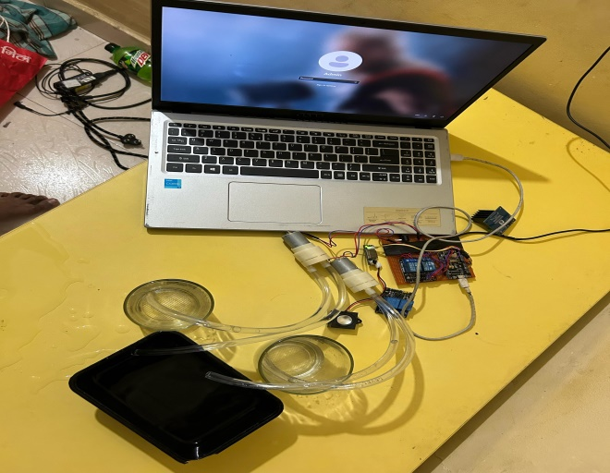

**Result and Discussion**

Voice-based hot water dispenser combines voice recognition technology with intelligent temperature control to provide users with the advantages of hands-free operation .It accurately responds to voice commands of a variety of water temperatures and volumes, ensuring ease of use and accessibility .The system has energy savings with an automatic shutoff mechanism to avoid waste, providing a fluid and practical experience.

**Conclusion** – In summary, the Voice-Based Hot and Cold Water Dispenser is a convergence of intelligent technology and easy voice commands, providing ease and accessibility. Its high- efficiency design and frictionless operation make it the perfect solution for personal and public use. CHAPTER 8 Future Scope – he future direction of the Voice-Based Hot and Cold Water Dispenser is integration with AIpowered personalization, which enables the system to learn users' preferences gradually. The future direction could also involve integration with smart home ecosystems and developing more eco-friendly, sustainable materials for greater energy efficiency.

**Reference** –

[1] Z. Zhu, X. Li, M. Chen, and Y. Wang, “Advancements in voice assistants and smart home technology,” Journal of Smart Technologies, vol. 12, no. 3, pp. 45–58, 2019.

[2] H. Xu, T. Zhang, and L. Sun, “IoT-based water distributors for automated temperature control,” Journal of Internet of Things Applications, vol. 15, no. 2, pp. 78–89, 2020.

[3] S. Borsci, F. Federici, and L. Mele, “The impact of voice-controlled systems on accessibility,” Universal Access in the Information Society, vol. 20, no. 4, pp. 601–615, 2021.

[4] Y. Wang, X. Liu, and J. Chen, “Energy efficiency in smart devices and automated systems,” Energy Informatics Journal, vol. 10, no. 1, pp. 22–34, 2018.

[5] D. Jurafsky and J. H. Martin, Speech and Language Processing, 3rd ed. Prentice Hall, 2021.

[6] W. Xiong, L. Wu, F. Alleva, J. Droppo, X. Huang, and A. Stolcke, “The Microsoft 2018 conversational speech recognition system,” in Proc. IEEE Int. Conf. Acoust., Speech, Signal Process. (ICASSP), 2018, pp. 5934–5938.

[7] J. Gubbi, R. Buyya, S. Marusic, and M. Palaniswami, “Internet of Things (IoT): A vision, architectural elements, and future directions,” Future Gener. Comput. Syst., vol. 29, no. 7, pp. 1645–1660, 2013.